Table of Contents

1 Table of Figures 1

2 Table of Tables 1

3 Table of Equations 1

4 Subsystem One: Relative Position of Pilot 2

4.1 Definition and Requirement 2

4.2 Background and Prior Art 3

4.3 Approach and Execution 5

4.4 Results and Discussion 11

5 Bibliography 12

# Table of Figures

Figure 7: SS1 Breakdown 2

Figure 8: IR Proximity Sensing 4

Figure 9: TRCT5000 (Vishay Semiconductors, 2017) 6

Figure 10: TRCT5000 Topology 7

Figure 11: IR Sensor Mount Header Topology 7

Figure 12: IR Sensor Mount PCB Depiction 8

Figure 13: Fabricated IR Sensor Mount PCB 8

Figure 14: Hose Clamp (Bunnings, 2018) 9

Figure 15: Cable Tie (Computer Cable Store, 2018) 9

Figure 16: Mount Structure 10

Figure 17: Mount Structure (Single) CAD 10

Figure 18: Printed Mount Structure (Single) 10

Figure 19: Sensor Frame 11

Figure 20: Constructed Sensor Frame 11

Figure 21: Subsystem One (Assembled) 11

# Table of Tables

No table of figures entries found.

# Table of Equations

No table of figures entries found.

# Subsystem One: Relative Position of Pilot

This section details the analysis, design, implementation, and results of the subsystem responsible for the perception of the position of the pilot relative to the exoskeleton.

## Definition and Requirement

The overarching purpose of subsystem one (SS1) was to detect the position of the pilot relative to the position of the exoskeleton in real time. This may be accomplished, as noted in **Error! Reference source not found.**, by measuring the position of limbs in relation to fixed rotational axis on suit.

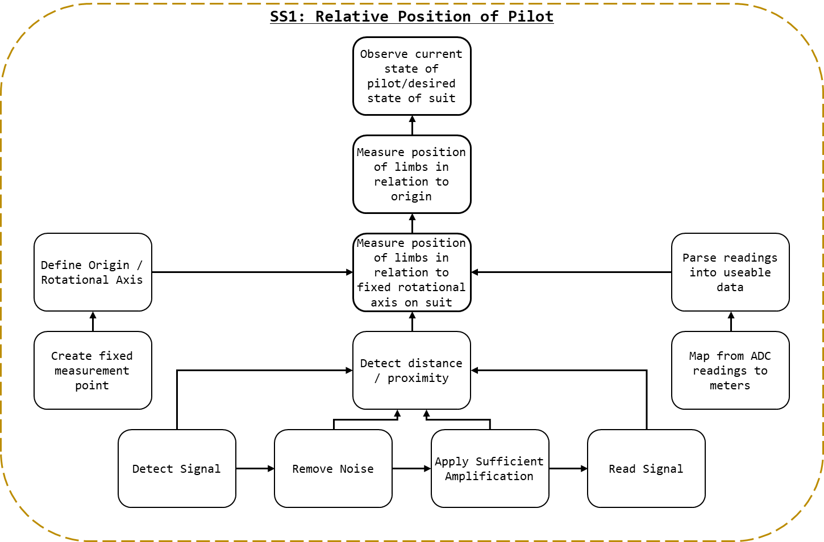

Figure 1: SS1 Breakdown

As detailed in Figure 1: SS1 Breakdown, to measure the position of limbs in relation to fixed rotational axis on suit:

* a fixed rotational axis must be defined;
  + this implies a fixed point where readings can be taken, as such, a mechnism for fastening the detection system must be devised.
* the position/distance must be measured; and,
* the measured distance must be parsed from raw values into useable data.
  + Functionally, this is the process of deriving the function that maps raw analogue voltage values to distance.

The process of measuring the distance will ostensibly entail:

* detecting a signal; the specific type will depend on the techonlogy selected (e.g. IR light, ultrasonic waves, magnetic field strength, etc);
* removing noise from the detected signal; ostensibly through the use of a filter;
* amplifying the cleaned up signal into a range suitble for reading; and,
* reading the signal, ostensibly with an ADC, into a format that can be parsed by the control systems.

## Background and Prior Art

The process of defining the fixed rotational axis and parsing readings into distance values are dictated by the system and are less subject to variation and subjectivity. Instead, the focus on researching prior art for SS1 was determining the most appropriate mechanisms for detecting distance. Additionally, research was conducted on appropriate filtering and amplification methods. The requirements for reading the signals synthesised are outlined, but the selection of a microcontroller for interfacing with all five subsystems is detailed in **Error! Reference source not found.**.

### Perceiving Distance

This section details many of the technology considered for perceiving the proximity of the pilot’s limbs. The sensor types given the most serious consideration are detailed here, with additional sensors types considered found in **Error! Reference source not found.**.

#### IR Transceiver

Infrared light, or IR, is a form of electromagnetic (EM) radiation general not visible to human eye’s (Lynch & Livingston, 2001). The wavelength of IR is typically defined as ranging from 700 nanometres (frequency 430 THz) to 1 millimetre (300 GHz) (Liew, 2018). IR is emitted by the sun, artificial lighting, fires, as thermal radiation from objects (and animals), and from IR emitters (American Technologies Network Corporation, 2018).

The prototypical IR emitter is a light emitting diode (LED) composed to emit IR when power. They typically share a formfactor with standard LEDs and are often used in IR communication. To receive a signal transmitted via an IR emitter and IR received is used. IR receivers may take the form of a photoresistor configured for IR range light. IR emitters and receivers are often used in concert to transmits a message (via the emitter) and then receive it (via the receiver) (Future Electronics, 2018).

Like all EM waves, IR suffers from attenuation (Garbett, 2001). IR is also capable of being reflected off a non-absorbing material. As seen in Figure 2: IR Proximity Sensing, by emitting IR (A) and measuring the intensity of the light reflected (B) it is possible to determine the distance from the reflective surface (C) and the emitter. This principle may be applied to determine the distance of an object from a transceiver (IR emitter/transmitter and receiver).

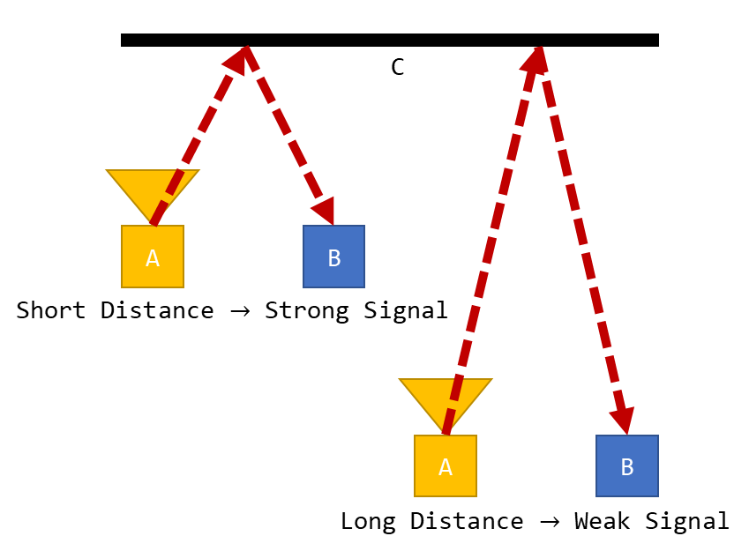

Figure 2: IR Proximity Sensing

IR is an effective method of detecting range, in fact IR is often employed in LiDAR (Cracknell & Hayes, 2007). Assuming line of sight exists between the reflection point and the IR receiver there is no minimum range. Additionally, IR technology is small, affordable, and ubiquitous. Under ideal conditions an IR transceiver would be capable of perceiving the instance between an exoskeleton and its pilot.

Outside of ideal conditions complications with IR technology can occur. As noted above, IR is ubiquitous and is emitted by the sun, artificial lighting, and animals meaning that even if all undesirable frequencies (e.g. the 38kHz carrier signal from most IR remotes) where filtered from an IR signal noise may still exist. Under poor operating conditions an IR transceiver may be saturated with IR rendering it effectively blind. Additionally, variability in the reflective surface may result in IR being reflected inconsistently or not at all. Under these conditions mapping from signal intensity to distance may be impossible, as different surfaces will yield different signal intensities.

### Filters and Amplification

This section details the theory required for understanding the requirements and design of the filter and amplifier designed for the proximity perception system.

Filters are applied in order to remove noise from a signal, noise defined as “irrelevant or meaningless data or output occurring along with desired information” (Merriam-Webster Dictionary, 2018). An active filter is a filter that uses active components (e.g. operational amplifiers), rather than entirely passive components. Depending on the nature of the noise present in a measured input specific input ranges may need to be filtered (e.g. unwanted frequencies).

A low pass filter is a filter that permits lower frequency signals and filters high frequency noise, with a high pass performing the opposite function. In the case where a specific signal frequency is desired a high pass and a low pass filter may be combined to allow a specific band of frequencies to remain. This configuration is known as a band pass filter.

A common and useful electronic filter topology is the Sallen–Key topology. The Sallen–Key topology is an electronic filter topology that allows for the simple implementation for a second order filter. Seen in kt, a band pass filter may by implemented in Sallen–Key topology.

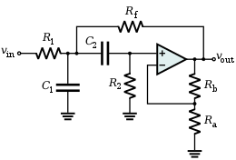

By performing analysis on the circuit depict in figure kt, it is possible to determine the system response of a Sallen–Key bandpass filter.

TALK ABOUT WHAT EQUATIONS WE GET AND HOW THEY CAN BE USED HERE

Kt kt kt

Amplification can be applied to signal to increase its intensity. Within the finite window that is inherent to all measurement mechanisms amplification may be used to increase or decrease the relative signal strength so that the area of interest aligns with the range of measurement. In the context of proximity sensing where the signal intensity may vary (e.g. IR range finding) it may be possible amplify the specific regions on interest. For example, for a signal that ranges between 0-5V for a range of 0-1m being read by and ADC (analogue to digital converter) with a 0-5V range, it may be possible to amplify the signal such that the 10-20cm range constitutes the entire 0-5V range received by the ADC.

## Approach and Execution

### Perceiving Distance

When considering the conditions of operation, the distance perception system was expected to take reading from shifting, rippling, flexing human body parts. Body parts which may be clothed, shaved, hairy, firm, or soft. Body parts with rounded uneven surfaces at close ranges.

The conditions of operation featured many unknowns and the specific approach selected for the actuators could not be known prior to selection of the proximity sensing method (the significant delays would have been untenable). As such, the possibility of acoustic noise in the actuation system or the environment in general could not be dismissed.

Given this understanding of the operating conditions, ultrasonic sensors were considered inappropriate for the creation of a robust design within the constraints of the project.

IR range sensing was selected as the approach for determining distance. The Vishay TCRT5000 - Reflective Optical Sensor with Transistor Output was selected for the IR range sensing (Vishay Semiconductors, 2017), see Figure 3: TRCT5000 (Vishay Semiconductors, 2017). As stated by the manufacturer “The TCRT5000 and TCRT5000L are reflective sensors which include an infrared emitter and phototransistor in a leaded package which blocks visible light. The package includes two mounting clips.” (Vishay Semiconductors, 2017).

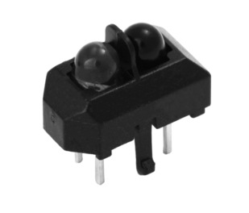

Figure 3: TRCT5000 (Vishay Semiconductors, 2017)

The TCRT5000’s datasheet may be found in the attached documents as “TCRT5000 - Reflective Optical Sensor with Transistor Output.pdf”. The following circuit was used for the configuration of the TRCT5000s within the project, see Figure 4: TRCT5000 Topology, where **SIG** represents the output signal.

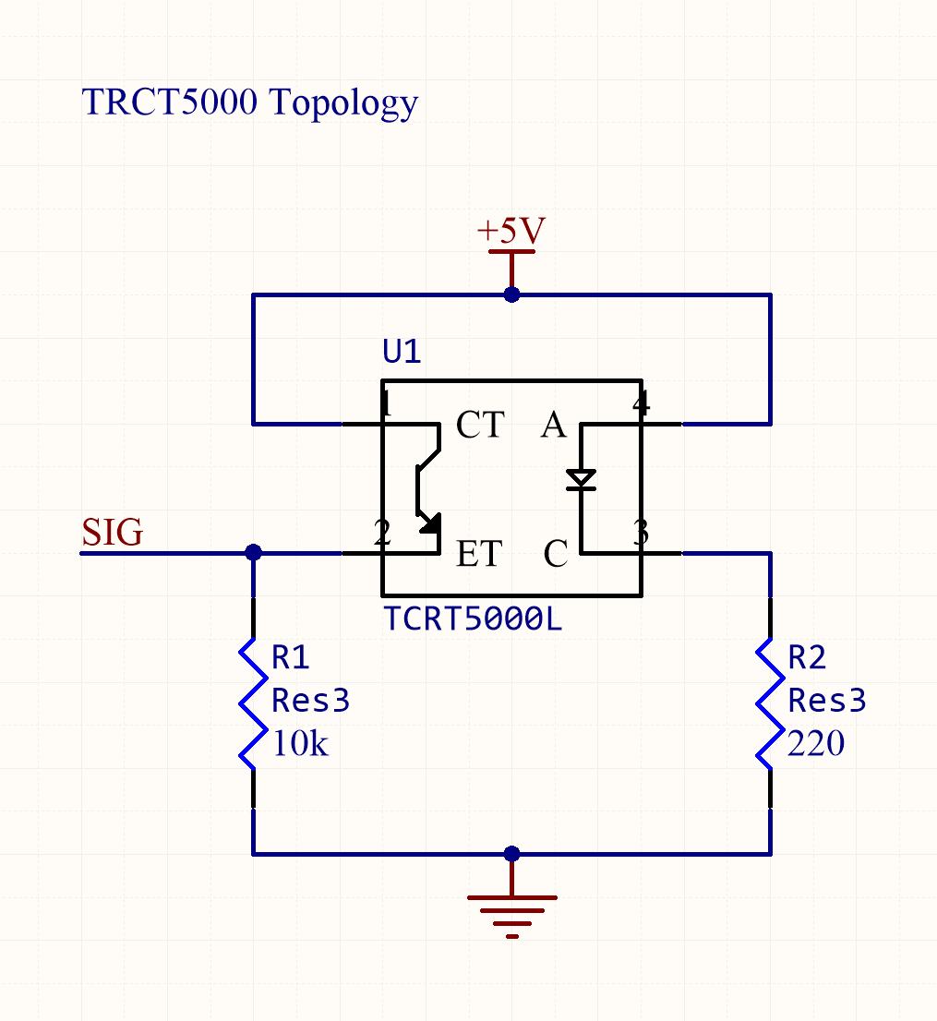

Figure 4: TRCT5000 Topology

A printed circuit board (PCB) would be created to which an IR transceiver, or emitter and receiver, could be mounted. The PCB would be designed as such that it would interface with external systems by only power and signal cables. Ideally, the IR PCB would be modular, and in the case of damage, simply replaced with another like it. This circuit board would feature the circuit in Figure 4: TRCT5000 Topology and the header depicted in Figure 5: IR Sensor Mount Header Topology.

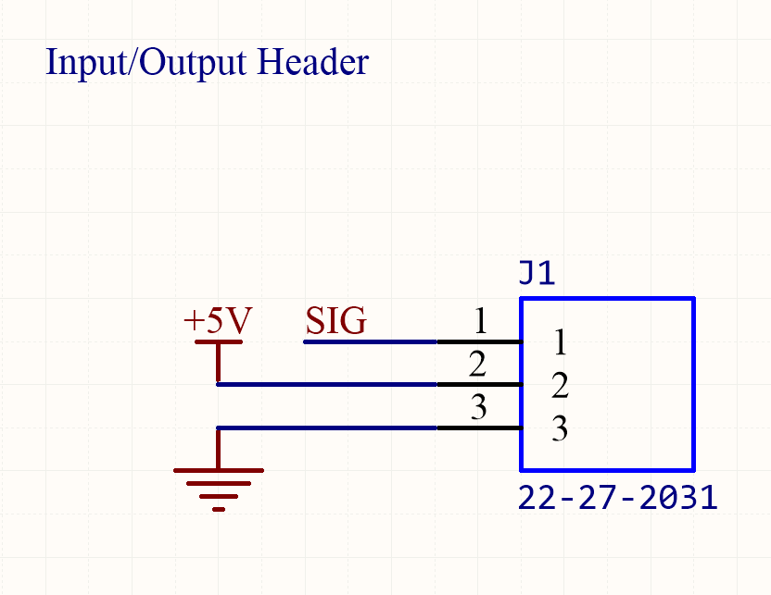

Figure 5: IR Sensor Mount Header Topology

The PCB was designed in Altium Designer (16.1), the PCB schematic may be found in the attached documents under the designation “IR Sensor Mount” and shown in Figure 6: IR Sensor Mount PCB Depiction.

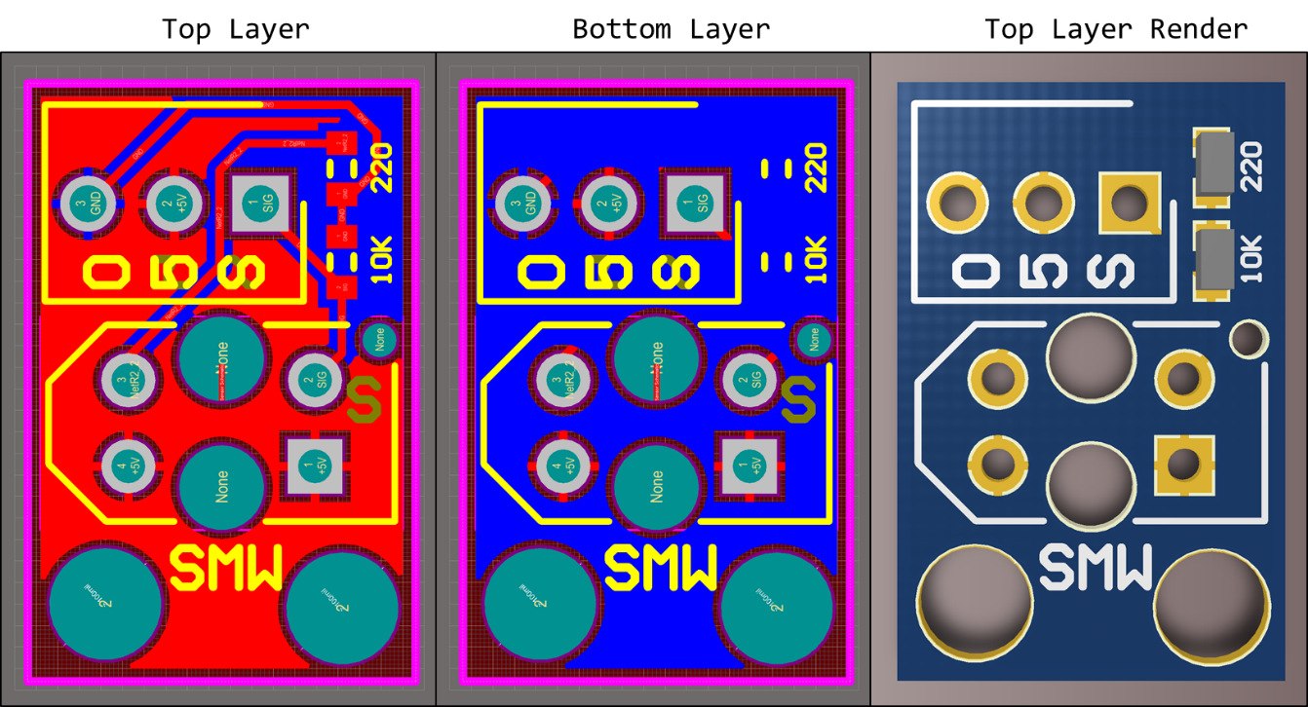

Figure 6: IR Sensor Mount PCB Depiction

The PCBs were fabricated and assembled as shown in Figure 7: Fabricated IR Sensor Mount PCB.

Kt

Figure 7: Fabricated IR Sensor Mount PCB

### Fixed Rotational Axis

The fixed rotational axis upon which distance measurements would be referenced was determined to be the hip, knee, and ankle joints where ostensibly the actuators axis were to be place. As noted in **Error! Reference source not found.**, this considerable simplifies the kinematics and controls of the system. However, as the size of the exoskeleton and the limb segments devised was dependent on the mechanical build by those responsible for the actuation system estimations where required for the majority of the project regarding the specific length of limbs.

While it was presumed the exoskeleton’s structural systems would be on the external sides of the pilot’s body, the mounts for the position detection system would be designed without specifies on materials or dimensions of the exoskeleton (these values would remain unconfirmed until exceedingly late within the project).

It could not be presumed that the exoskeleton segments would have free ends, so the system would need to be designed to be attached, firmly, to a rod of an arbitrary shaped cross section of an arbitrary size, without access to a free end. It was required that wobbling vibration, ro movement of any kind was to be minimised and the connection would be remove and reattached an indeterminant number of times. The connection needed to be fast, simple, and not so complicated to introduce risks of improper application.

Hose clamps were identified as a suitable fastener method. Screw/band (worm gear) clamps, see Figure 8: Hose Clamp (Bunnings, 2018), are reusable, can be applied to a rod of an arbitrary shape and size (with ranges), affix firmly, and may be attached quickly with a screwdriver.

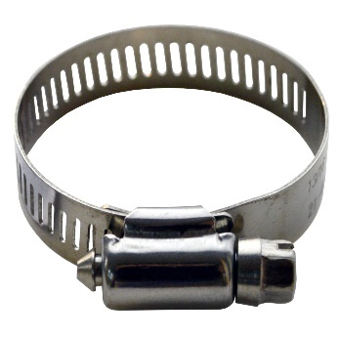

Figure 8: Hose Clamp (Bunnings, 2018)

However, as the details of the proposed exoskeleton became available it was noted that the cross section of exoskeleton frame may have been as small as 5mm in diameter. A size below the range of standard hose clamps. Instead, cable ties were identified as an ideal fastener method.

Seen in Figure 9: Cable Tie (Computer Cable Store, 2018), cable ties, or zip ties are a form of typically plastic ratcheting strap. The can be affixed to a rod of an arbitrary shape and size, attached by hand, and are disposable. While a less permanent solution for an attachment mechanism compared to hose clamps, the were deemed sufficient for a proof of concept.

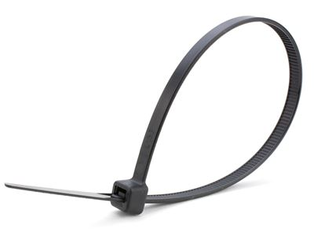

Figure 9: Cable Tie (Computer Cable Store, 2018)

To mount the measurement structure to the exoskeleton a plat was design that could sit flush to the frame. As seen in figure Figure 10: Mount Structure, the structure (black), could be mounted to the exoskeleton frame A. Seen from the side, gutters where placed (B) so cable ties could be affixed, while guard rails (C) ensured the cable ties did not slip or move during operation. The measurement structure and any auxiliary objects could be affixed at the surface of the plate (D) with counterbored sections (E) for nuts and bolts to be mounted while sitting flush with the surface of the exoskeleton.

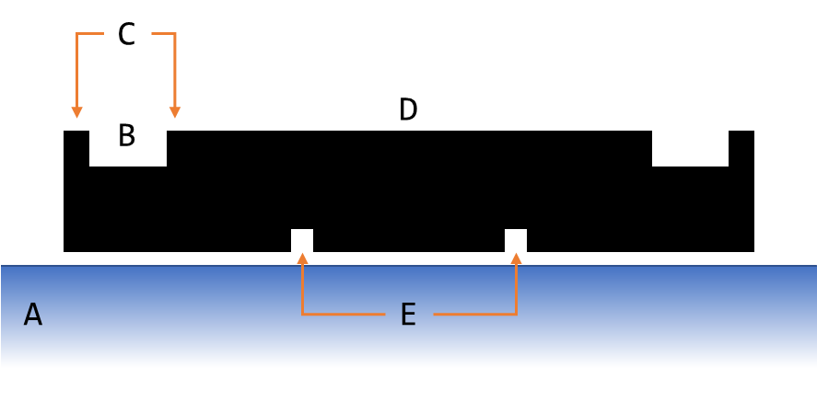

Figure 10: Mount Structure

The component was created in Autodesk Inventor, as seen in Figure 11: Mount Structure (Single) CAD. Attached to this document full CAD files for all components can be found kt.

Kt

Figure 11: Mount Structure (Single) CAD

To minimise the weight of this component and ease in manufacturing, the mounting plate was constructed via 3D printing, see Figure 12: Printed Mount Structure (Single).

kt

Figure 12: Printed Mount Structure (Single)

Presuming a fixed mounting place (as given by the mount structure) a scaffolding structure would be required to mount the IR sensor PCBs in place. After testing the effective range of the IR sensors created it was determined that two sensors working in tandem provided the most reliable measurements of position. Two sensors doubled the effective IR emitted, and given the irregular surfaces of the human body, the readings could be averaged to give a more consistent reading.

In the circumstance of trying to maintain a consistent offset from the pilot, as noted in kt (controls), the goals of the control systems is not to maintain an exact distance from the pilot, but maintain the safe distance on either side of the pilot. Rather than a solution comprised of measuring the pilot and attempting to maintain a specific offset, sensors on either side of the pilot could be used to detect the difference in the offset on both sides.

The design depicted in Figure 13: Sensor Frame was created. The frame (B) would envelope the pilot (A), and attach to the mount structure (F), see Figure 10: Mount Structure, on the outside edge of the pilot. A pair of sensors would detect in tandem (C) on either side the pilot (D), effectively measuring the position of the front and back of their leg in relation to the actuation of the exoskeleton.

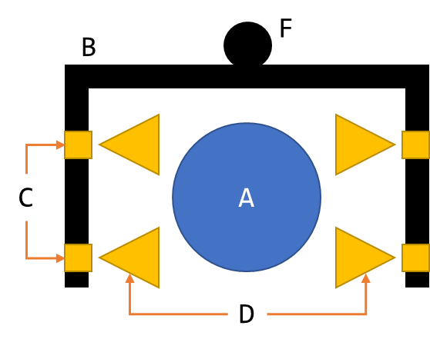

Figure 13: Sensor Frame

As shown in Figure 14: Constructed Sensor Frame, the sensor frame was constructed from aluminium, and later wood. Aluminium was selected for is strength and weight (relative to other metals). Once tested using the rig developed in **Error! Reference source not found.**, a lighter material was sought. Wood was selected. While adequate for a prototype, the materials used should be replaced with lighter plastic or carbon fibre materials for future designs; the structural requirements of the system are minimal and weight reduction is a priority.

kt

Figure 14: Constructed Sensor Frame

### Mapping Values

kt

## Results and Discussion

The final system was commissioned and assembled, as shown in Figure 15: Subsystem One (Assembled) .

Figure 15: Subsystem One (Assembled)

How well did it work?

# Bibliography

Agarwal, A. (2005). *Foundations of analog & digital electronic circuits* (1 ed.). Massachusetts: Massachusetts Institute of Technology. Retrieved June 1, 2018, from https://www.google.com/url?sa=t&rct=j&q=&esrc=s&source=web&cd=1&ved=0ahUKEwiBu7yQl7LbAhUEoZQKHfYlBzkQFggpMAA&url=http%3A%2F%2Fsiva.bgk.uni-obuda.hu%2Fjegyzetek%2FMechatronikai_alapismeretek%2FEnglish_Mechatr%2FElectr_Eng-1%2FLiterature%2FFoundations%2520o

American Technologies Network Corporation. (2018, May 30). *How Does Night Vision Work*. Retrieved from atncorp.com: https://www.atncorp.com/hownightvisionworks

Arrow. (2018). *Magnetoresistive Sensor.* Retrieved May 30, 2018, from arrow.com: https://www.arrow.com/en/categories/sensors/magnetoresistive-sensors

Axe, D. (2012, May 23). *Combat Exoskeleton Marches Toward Afghanistan Deployment*. Retrieved May 30, 2018, from Wired: https://www.wired.com/2012/05/combat-exoskeleton-afghanistan/

Bulgrin, M. (2017, May 11). *The History of the Hose Clamp.* Retrieved from normagroup.com: https://blog.normagroup.com/en/the-history-of-the-hose-clamp/

Bunnings. (2018, May 31). *Kinetic 21 - 44mm 304 Stainless Steel Hose Clamp.* Retrieved May 31, 2018, from Bunnings.com: https://www.bunnings.com.au/kinetic-21-44mm-304-stainless-steel-hose-clamp_p4920194

Charara, S. (2015, July 9). *This robotic exoskeleton helps paralysed patients to walk and it's getting smarter*. Retrieved August 23, 2017, from Wearable: https://www.wareable.com/wearable-tech/exoskeleton-paralysed-patients-ekso-bionics-gt-sarah-thomas

Computer Cable Store. (2018, May 31). *11 7/8 Inch Black Standard Nylon Cable Tie - 100 Pack.* Retrieved May 31, 2018, from computercablestore.com: https://www.computercablestore.com/11-78-inch-black-standard-nylon-cable-tie-100-pack

Cornwall, W. (2015, October 15). *Feature: Can we build an ‘Iron Man’ suit that gives soldiers a robotic boost?* Retrieved August 20, 2017, from sciencemag.org: http://www.sciencemag.org/news/2015/10/feature-can-we-build-iron-man-suit-gives-soldiers-robotic-boost

Cracknell, A. P., & Hayes, L. (2007). *Introduction to Remote Sensing* (2 ed.). London: Taylor and Francis. Retrieved May 30, 2018

Cutnell, J. D., & Johnson, K. W. (1998). *Physics* (4th ed.). New York: Wiley.

Cyberdyne. (2015, August 1). *CYBERDYNE Inc. has begun seeking approval from the U. S. Food and Drug Administration (FDA)*. Retrieved August 23, 2017, from cyberdyne.jp: https://www.cyberdyne.jp/english/company/PressReleases_detail.html?id=1075

Cyberdyne. (2016). *What’s HAL?* Retrieved August 19, 2017, from cyberdyne.jp: https://www.cyberdyne.jp/english/products/HAL/

Cybernetic Zoo. (2010, October 14). *1890 – Assisted-walking Device – Nicholas Yagn (Russian)*. Retrieved May 30, 2018, from Cyberneticzoo.com: http://cyberneticzoo.com/tag/nicholas-yagn/

Cybernetic Zoo. (2010, April 10). *1965-71 – G.E. Hardiman I Exoskeleton – Ralph Mosher (American)*. Retrieved May 30, 2018, from cyberneticzoo.com: http://cyberneticzoo.com/man-amplifiers/1966-69-g-e-hardiman-i-ralph-mosher-american/

Dawkins, P. (2018). *Differential Equations - Notes - Laplace’s Equation*. Retrieved June 3, 2018, from Paul's Online Math Notes: http://tutorial.math.lamar.edu/Classes/DE/LaplacesEqn.aspx

Dunietz, J. (2017, July 27). *Robotic Exoskeleton Adapts While It’s Worn*. Retrieved August 20, 2017, from scientificamerican.com: https://www.scientificamerican.com/article/robotic-exoskeleton-ldquo-evolves-rdquo-while-its-worn/

Future Electronics. (2018, May 30). *What is Optoelectronics?* Retrieved from Future Electronics: http://www.futureelectronics.com/en/optoelectronics/infrared-receivers.aspx

Garbett, I. (2001, Janurary 1). *Light attenuation and exponential laws*. Retrieved May 30, 2018, from plus.maths.org: https://plus.maths.org/content/light-attenuation-and-exponential-laws

Golnaraghi, F., & Kuo, B. C. (2010). *Automatic Control Systems* (9 ed.). Hoboken: John Wiley & Sons, Inc. Retrieved June 4, 2018

Gross, K. (2018, Feburary 19). *Ultrasonic Sensors: Advantages and Limitations*. Retrieved May 30, 2018, from MaxBotix: https://www.maxbotix.com/articles/advantages-limitations-ultrasonic-sensors.htm/

Jackson, R., Green, K. R., & Eisenbeis, R. (2017). *Achieve greater precision, reliability with integrated magnetic sensing technology.* Retrieved May 30, 2018, from ti.com: http://www.ti.com/general/docs/lit/getliterature.tsp?baseLiteratureNumber=sszy030&fileType=pdf

Karlin, S. (2011, July 29). *Raytheon Sarcos’s Exoskeleton Nears Production*. Retrieved August 11, 2017, from spectrum.ieee.org: http://spectrum.ieee.org/at-work/innovation/raytheon-sarcoss-exoskeleton-nears-produc

Keller, M. (2016, August 25). *Exoskeleton - Do You Even Lift, Bro? Hardiman Was GE’s Muscular Take On The Human-Machine Interface*. (General Electric) Retrieved May 30, 2018, from GE Reports: https://www.ge.com/reports/do-you-even-lift-bro-hardiman-and-the-human-machine-interface/

Keyence Corporation. (2018). *What is a Inductive Proximity Sensor?* Retrieved May 30, 2018, from keyence.com: https://www.keyence.com/ss/products/sensor/sensorbasics/proximity/info/

Khatib, O. (2008). Chapter 5 - Dynamics. In O. Khatib, *Introduction to Robotics* (pp. 125-150). Stanford: Stanford University.

Liew, S. C. (2018, May 30). *Electromagnetic Waves*. Retrieved from Centre for Remote Imaging, Sensing and Processing.: https://crisp.nus.edu.sg/~research/tutorial/em.htm

Lynch, D. K., & Livingston, W. C. (2001). *Color and Light in Nature* (2nd ed.). Cambridge, United Kingdom: Cambridge University Press. Retrieved May 30, 2018, from https://books.google.com.au/books?id=4Abp5FdhskAC&pg=PA231&redir_esc=y#v=onepage&q&f=false

Merriam-Webster Dictionary. (2018, May 18). *noise*. Retrieved May 30, 2018, from merriam-webster.com: https://www.merriam-webster.com/dictionary/noise

National Instruments. (2018). *PID Theory Explained.* Retrieved June 4, 2018, from NationalInstruments.com: http://www.ni.com/white-paper/3782/en/

Ogata, K. (2010). *Modern Control Engineering* (2 ed.). New Jersey, United States of America: Prentice Hall. Retrieved August 25, 2017

Otaga, K. (2004). *System Dynamics* (4 ed.). Upper Saddle River: Pearson. Retrieved June 4, 2018

Robomart. (2015, November 9). *Advantages and Disadvantages of ultrasonic distance sensor.* Retrieved May 30, 2018, from Robomart: http://roboticsensors.blogspot.com/2015/11/advantages-and-disadvantages-of.html

Siciliano, B., & Khatib, O. (2016). *Springer Handbook of Robotics* (2 ed.). (B. Siciliano, & O. Khatib, Eds.) Berlin: Springer Nature. doi:10.1007/978-3-319-32552-1

Texas Instruments Incorporated. (2017). *Hall effect sensors*. Retrieved May 30, 2018, from ti.com: http://www.ti.com/sensing-products/magnetic-sensors/hall-effect/overview.html

Thomas Publishing Company. (2018). *Capacitive Proximity Sensors*. Retrieved May 30, 2018, from Thomas: https://www.thomasnet.com/articles/instruments-controls/proximity-sensors

Vishay Semiconductors. (2017, February 8). TCRT5000 - Reflective Optical Sensor with Transistor Output.

Yagin, N. (1890, February 11). *United States of America Patent No. 440684.*

Yuhas, D. (2012, May 24). *Speedy Science: How Fast Can You React?* Retrieved from scientificamerican.com: https://www.scientificamerican.com/article/bring-science-home-reaction-time/

ZJIA. (2018, June 1). *Generic YZC-161B 50kg Body Scale Sensor Human Scale Weighing Load Cell Sensor (Pack of 4)* . Retrieved June 1, 2018, from Amazon.com: https://www.amazon.com/Generic-YZC-161B-Scale-Sensor-Weighing/dp/B00MTJ6WZ2